George Memorial Library

Google Docs: A Beginners Guide

Google Docs Interface
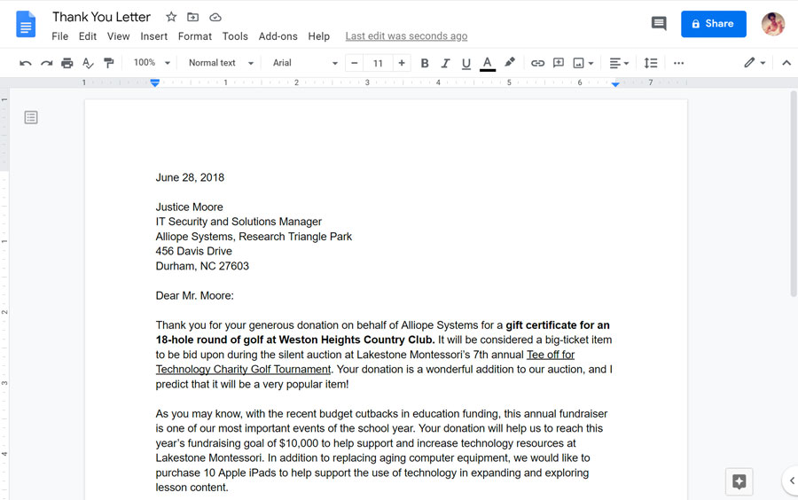
The Google Docs interface includes the toolbar at the top of the screen, as well as the document itself. It allows you to type and modify text, in addition to sharing a document with others.
- Document Title: Google Docs displays the title of your document on the top of your sccreen and on your Google Docs homepage. By default, new documents are named Untitled document. Click the title to change the document name.
- Saved Changes Notification: Google Docs automatically saves your changes as you work. The saved changes notification lets you know that your document has been saved.
- Menu Toolbar Menu: Various menus for working with your document can be found on the Menu toolbar. Click a menu to see available commands and options.
  - Edit: Cut, Copy, Paste, Undo, and Redo
  - Insert: Insert elements (from images to page numbers)
  - Format: Use to customize font, page layout, and paragraph style.
  - Tools: lets you access several useful tools in Google Docs, like a spellchecker, dictionary, outline generator, word count, automatic dictation, translator, script editor, and automatic substitution.
  - Extensions

Page Setup Options
When you first create a Google document, you may want to change page setup options like page orientation, margins, or paper size, depending on the type of document you are creating. You can access these options by clicking Page setup in the File menu.
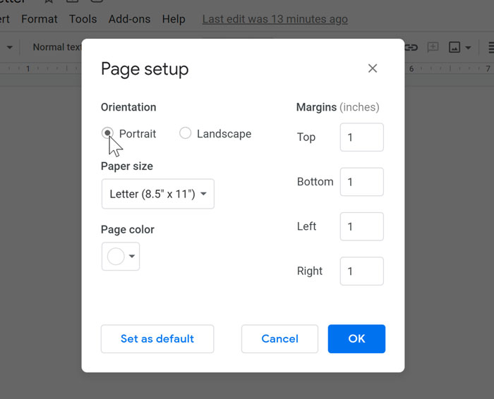
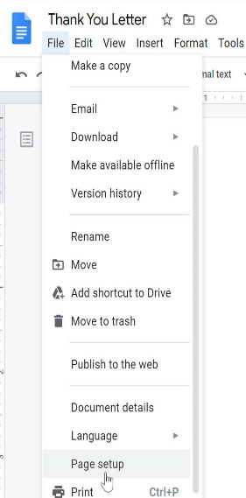
- Page orientation is whether your page is oriented in portrait or landscape format. Landscape format means the page is oriented horizontally, while portrait format means it is oriented vertically.
- Page margins are the gaps between the body of the document and the edge of the page.
- Paper size lets you change the dimensions of the page. This is particularly useful if you are printing the document on a custom paper size.
- Page color is the background color of the document. This may be useful as a decorative option if you plan on publishing your document on the Web.

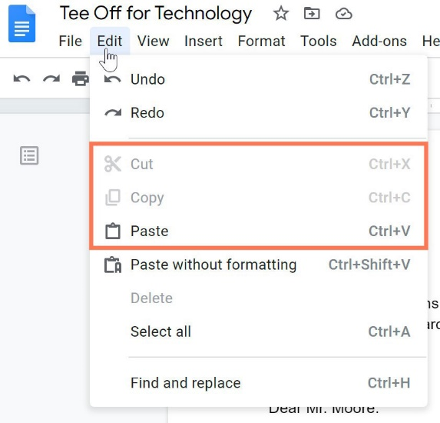
Text Editor

Copying and Pasting Text
The copy, cut, and paste commands are found in the Edit menu. Google Docs also uses keyboard shortcuts—or a combination of keys—to perform a variety of commands.

To Copy and Paste Text
- Select the text you want to copy.
- Press Ctrl+C (Windows) on your keyboard to copy the text.
- Place your insertion point where you want the text to appear.
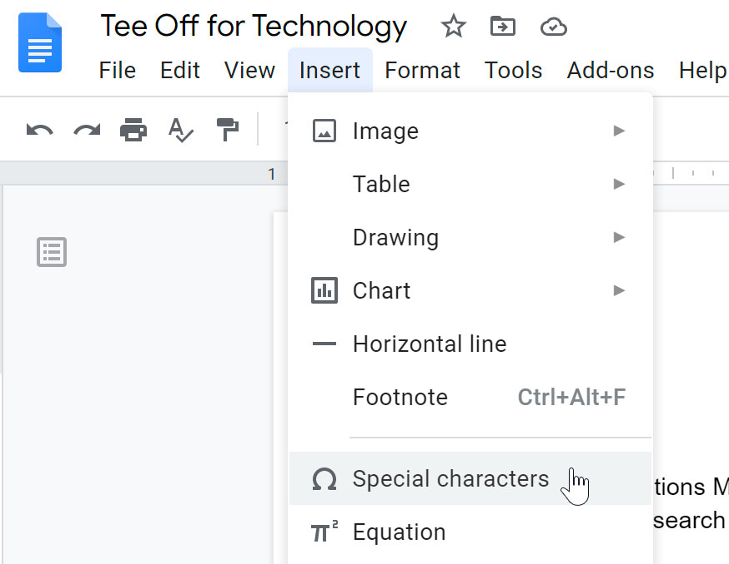
- Press Ctrl+V (Windows) on your keyboard to paste the text. The text will appear.

To insert special characters:
Google Docs offers a large collection of special characters. They are useful when writing equations, and they can serve as decorative accents as well.
- Place the insertion point where you want to insert a special character.
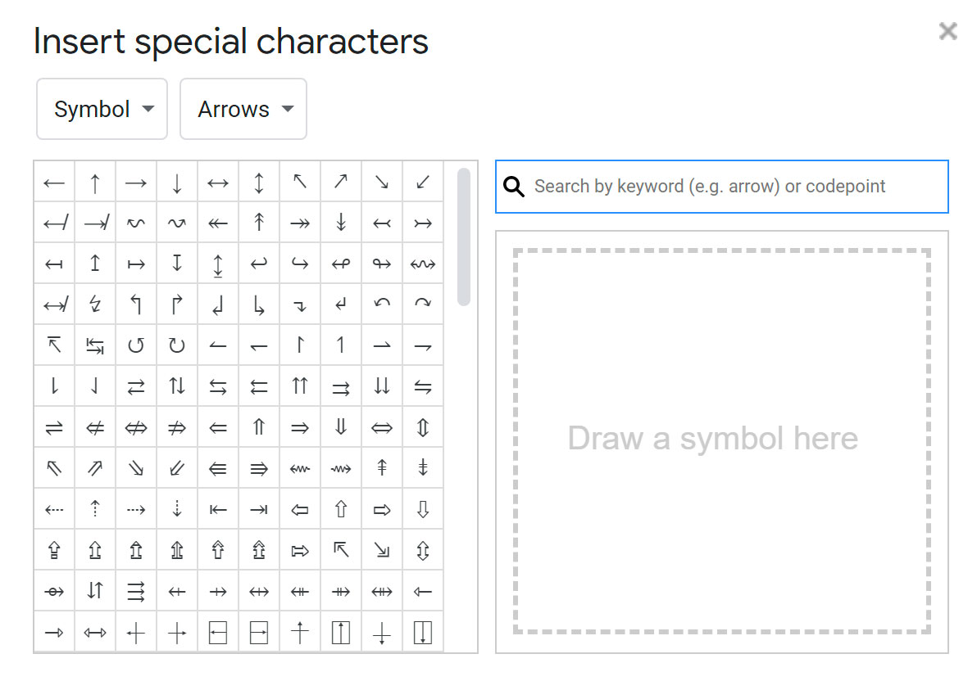
- Click Insert, then select Special characters.
- The Insert Special Characters dialog box will appear.
- Use the drop-down arrows above the character grid to browse groups of symbols.
- Click the desired symbol to insert it into your document.
- The symbol will appear in your document.

Spell check and suggested spelling
By default, Google Docs will automatically check for misspelled words and make suggested spellings. Words with spelling suggestions are underlined in red.
To use suggested spelling:
- Right-click an underlined word. A drop-down menu with suggested spellings for the misspelled word will appear. Select the correct spelling from the list.
- The correct spelling will appear in place of the misspelled word in the document.
NOTE: Occasionally, Google Docs will suggest spellings for a word it does not recognize, like the name of a person or a company. If you are certain of the spelling, you can add the word to the dictionary. Once you add a word to the dictionary, Google Docs will keep the spelling of the word.

Using find and replace
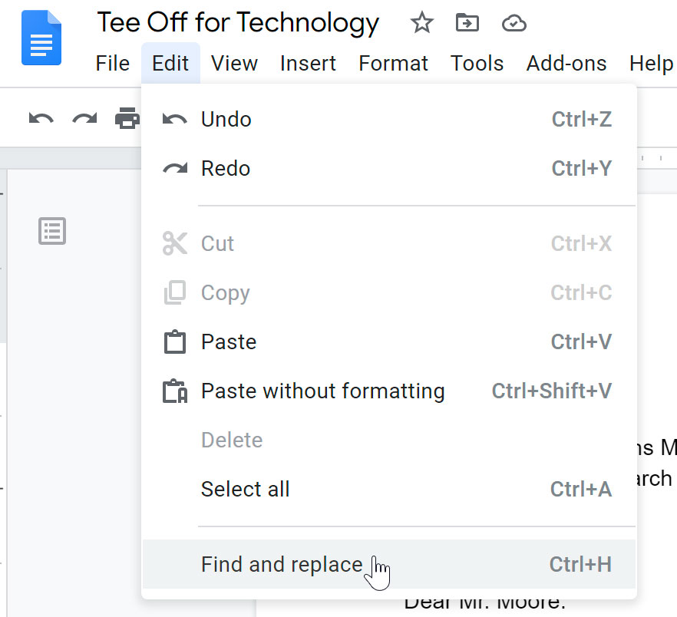
When you're working with longer documents, it can be difficult and time-consuming to locate a specific word or phrase within the document. Google Docs can automatically search your document using the find feature, and it even allows you to change words or phrases using the replace feature.
To find text:
- Click Edit, then select Find and replace.
- The Find and replace dialog box will appear.
- Type the text you want to find in the Find field. The number of times the word appears in the text will appear in the Find field, and each appearance will be highlighted throughout the document.
- If the word appears more than once, you can click the Prev and Next arrows to jump to the next appearance. When the word is selected, the highlight will darken and pulsate briefly.
- Click X to close the dialog box.
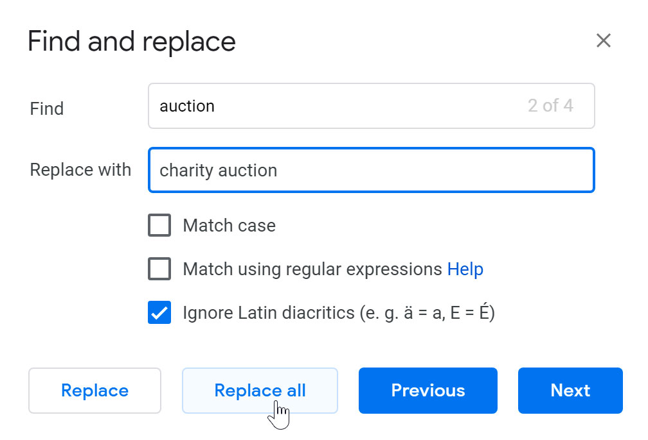
To replace text:
- Click Edit, then select Find and replace. The Find and replace dialog box will appear.
- Type the text you want to find in the Find field. Type the text you want to replace it with in the Replace with field.
- Click Next or Prev and then Replace to replace text. If you want to replace all occurrences of the text within the document, click Replace all.

Download a file
- Locate the File tab, and click on Download as. Then choose your desired file type. In this example, we will choose PDF Document.

Print a file
- Locate the File tab, and click Print.
- The Print dialog box will appear, along with a preview of your file on the right. Choose the desired options, then click Print.
Note that these options will vary depending on the type of file you're printing. For example, you'll have different options for printing a spreadsheet than you would for printing a presentation.

Uploading and syncing files
If you upload files from compatible programs like Microsoft Word or Excel, you can even edit them in Google Drive.
Once you upload a file—no matter what type of file it is—you'll be able to manage, organize, share, and access it from anywhere. And because the files on Google Drive are synced across your devices, you'll always see the most recent version of a file.
You can also preview many different file types, even if you don't have the software required for that file on your computer. For example, you can use Google Drive to preview a Photoshop file, even if Photoshop is not installed on your current computer.

To upload a file:
- From Google Drive, locate and select the New button, then select File upload.
- Locate and select the file(s) you want to upload, then click Open.
- The file(s) will be uploaded to your Google Drive.
Depending on your browser and operating system, you may be able to upload files by clicking and dragging a file from your computer into your Google Drive.
Tip: Once you start adding files to Google Drive, you can use folders to help organize and group them. This makes it easier to look for your files later and avoid digital clutter.

To delete a file
- Select the file you want to delete, then click the Remove button to move the file to the Trash folder.
Remember, Google gives you 15 GB of storage for free. If you ran out of space, you will have to pay for additional storage. I recommend deleting any files that are no longer relevant to you to avoid this extra charge.

Sharing Files
There are two ways to share documents with Google Drive. It all depends if the receiver has a Google account.
To share a file with someone with a Google account:
- Click the Share button.
- A dialog box will appear. In the People box, type the email addresses of the people you'd like to share the file with. If you want, you can add a message that will be emailed to the people you share the file with.
- Click Send. Your file will be shared.
Tip: For more control over your files, you can click the drop-down arrow to decide whether people can edit, comment on, or simply view the file.
To share a link:
- Click the Share button.
- A dialog box will appear. Click Get shareable link.
- A link to the file will be copied to your web clipboard. You can then paste the link in an email message or on the Web to share the file. When you're finished, click Done.

